**How to use DSL Rentals Service: Proxy DSL / Proxy 4G**

1. In order to use this service through HTTP protocol you need to put a domain and port information in your browser network settings.

*For Google Chrome browser:*

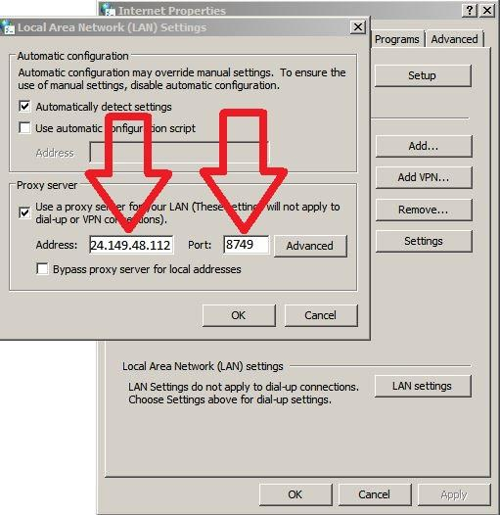

*For Mozilla Firefox browser:*

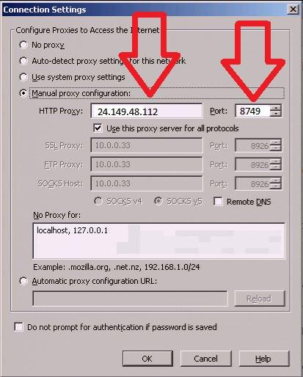

After that you will see an authentication window where you need to put your credentials.

In order to use this service through Socks5 protocol you need to install [FoxyProxy](https://chrome.google.com/webstore/detail/foxyproxy-standard/gcknhkkoolaabfmlnjonogaaifnjlfnp) add-on for your browser and put domain/port information and your credentials into the settings.

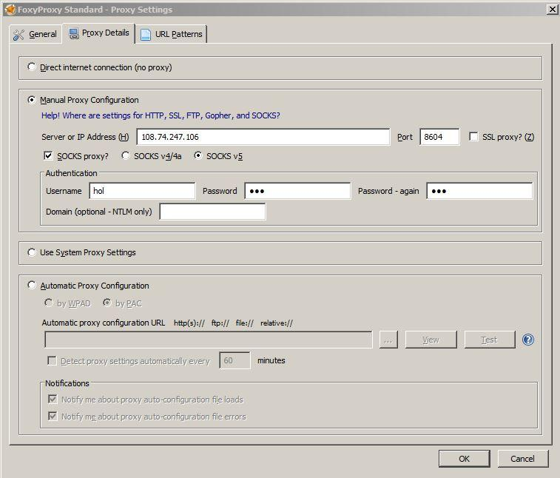

1. Using your control link you can track a status of your proxy connection and also you can change your IP and proxy type.



You can watch this video and see how our service works:

<https://www.youtube.com/watch?v=4QLap_vvLyI>

1. If you see in the control panel status “Proxy is OFF”, please send "Change IP" command one time to re-connect.

Please note: *After 1 hour without IP changes modem automatically turns off. To turn it back on, just press “Change IP” button in control panel.*

All necessary information including control link, point of access (domain and port) and login/password you can find in our information email.

If you have any question or any issues with our services you can request help through My Account - > Support.