**How to use DSL Rentals Service: Remote DSL/4G Servers**

1. In order to use this service you need to connect to our remote PC through TeamViewer.

We recommend using TeamViewer v6. You can download this version by link:

[*https://drive.google.com/open?id=1gJXjHREyzB35hU_CB0smH2_ItwFqrCDP*](https://drive.google.com/open?id=1gJXjHREyzB35hU_CB0smH2_ItwFqrCDP)

1. In order to change IP address you need to use our IPChanger application that you can find on the desktop.

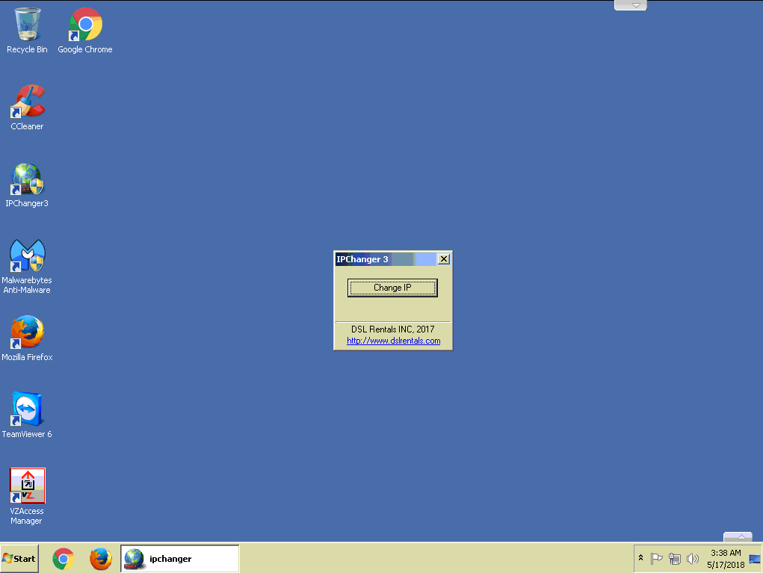

Please be advised: *After you click to Change IP, your server will disconnect from the Internet and will connect back with new IP address, so you need to close TeamViewer and reconnect back. This is not a problem, this is the way the system works.*

*IPChanger need time to obtain new IP. Sometimes it can take a little longer.*

1. Sometimes, at the work time, you can get a TeamViewer message saying that commercial use was suspected and your connection will be closed.

In order to fix this bug TV issue "Commercial Use Suspected!" please follow the instruction below:

[*https://www.youtube.com/watch?v=qPsmfNZ3jLg*](https://www.youtube.com/watch?v=qPsmfNZ3jLg)

*You need:*

*- Uninstall your TeamViewer application*

*- Delete all associated registry keys*

*- Change MAC address*

*- Restart computer*

*- Install TeamViewer application*

*You can download TMAC application by this link:*

[*https://drive.google.com/open?id=14kBIavLcbNDhpC07CnE2DhsNLKhhAEyF*](https://drive.google.com/open?id=14kBIavLcbNDhpC07CnE2DhsNLKhhAEyF)

If you have any question or any issues with our services you can request help through My Account - > Support.